**AI-powered Resume Screening and Ranking System**

A Project Report

submitted in partial fulfillment of the requirements

of

AICTE Internship on AI: Transformative Learning

with

TechSaksham – A joint CSR initiative of Microsoft & SAP

by

**KANDUKURI ABHINAV**

**kandukuriabhinav03@gmail.com**

Under the Guidance of

**Mr. SAOMYA CHAUDHURY**

**ACKNOWLEDGEMENT**

The satisfaction and euphoria that accompanies the successful completion of any task would be incomplete without the mention of the people who made it possible and whose encouragement and guidance have crowded our efforts with success.

First, I wish to express my heartfelt gratitude toward my mentor, **Mr. Saomya Chaudhury**, whose professional guidance, tireless encouragement, and editorial feedback were primarily responsible for guiding my understanding and strategy towards resume screening through AI. Their constant support and wisdom had a large influence on the direction of this project, and their constructive criticisms assisted me to navigate the development and research journey successfully.

I am also thankful to the member of the faculty **Mr. Pavan Sumohana** who have supported and created an environment conducive to excellence in academics. Their encouragement has helped develop my analytical and problem-solving skills during this process.

In addition, I am grateful for the rich support offered by **TechSaksham – A joint CSR initiative of Microsoft & SAP**. This project has provided me with an excellent chance to venture into the exciting realm of Artificial Intelligence, Data Science, and Streamlit-based UI development. The practical experience acquired through this project has been extremely rewarding, enhancing my technical skills and analytical skills.

I would like to express my sincerest gratitude to everyone who has helped in the successful implementation of this project. Without the assistance and advice of numerous persons and institutions, this project would have been impossible to achieve.

I would like to express our deep sense of gratitude and indebtedness to our college management for their kind support and permission to use the facilities available in the Institute.

Finally, I recognize the work of the open-source community and the many resources that have helped me in my research and development. The existence of these tools and information has been critical in being able to successfully create this project. This project has been a tremendous learning experience, and I am excited about its potential applications in the real world. The knowledge acquired and lessons learned will certainly be useful in my future projects.

#### **ABSTRACT**

The recruitment process is also becoming more and more difficult with the flood of applications received for every advertisement posted. Resume screening is a labor-intensive task, vulnerable to bias, and not very efficient which may be time-ingesting and inefficient whilst executed manually. This challenge affords an AI-primarily based totally resume screening and candidate rating device that automates the procedure the use of Natural Language Processing (NLP) and Machine Learning (ML) techniques. This system enables administrators to make job postings with informative requirements, enabling several users to upload PDF resumes. The uploaded resumes are vectorized and ranked based on TF-IDF and cosine similarity to indicate how relevant they are to the job description.

Most importantly, the system automatically gives greater weight to skills mentioned verbatim as required in the job description, enhancing the accuracy of the ranking. The system is developed with Streamlit for an easy-to-use web interface and SQLite for optimized data handling. The backend uses PyPDF2 for extracting text from PDFs and Scikit-learn for similarity calculations. The number one goal is to rank applicants primarily based totally on their relevance to a given task description, decreasing the guide attempt required through recruiters. The device extracts textual content from uploaded PDF resumes the use of pdfplumber and applies TF-IDF vectorization to convert textual information into numerical representations.

Cosine similarity is then used to degree the relevance of every resume to the task description. Additionally, customers can personalize rating weights for abilities and experience, permitting extra tailor-made assessment procedure. The effects are visualized via a rating desk and a bar chart representation. Keyword highlighting is likewise applied to emphasize vital qualifications withinside the resumes. Finally, recruiters can export the effects as a CSV report for similarly analysis.

Through the use of this system, This AI-based system minimizes the manual labor involved in candidate screening, enhances decision-making accuracy, and facilitates a more objective and unbiased screening process and recruiters are able to automate the hiring process, enhance candidate shortlisting effectiveness, and improve the overall recruitment process. This project illustrates the power of AI in HR technology and provides a platform for future development of automated recruitment tools.

**TABLE OF CONTENT**

**Abstract I**

**Chapter 1.**  **Introduction 1**

1.1 Problem Statement 1

1.2 Motivation 1

1.3 Objectives 2

1.4. Scope of the Project 3

1.5 Limitations……………………………………………………………3

**Chapter 2.**  **Literature Survey 4**

2.1 Consolidated Literature Survey……………………………………….4

2.2 Gaps and Limitations in Existing Solutions…………………………..6

**Chapter 3.**  **Proposed Methodology 8**

3.1 System Design………………………………………………………...8

3.2 Requirements Specifications…………………………………………12

3.2.1 Software Requirements ………………………………….………….12

**Chapter 4.**  **Implementation and Results ……………………………………….13**

4.1 Snapshots of Result…………………………………………………..13

4.2 GitHub Link for Code………………………………………………..16

**Chapter 5. Discussion and Conclusion …………………………………………17**

5.1 Future Work ………………………………………………………….17

5.2 Conclusion……………………………………………………………18

**References ……..…………………………………………………………………19**

**LIST OF FIGURES**

|  |  |  |
| --- | --- | --- |
| **Figure No.** | **Figure Caption** | **Page No.** |
| **3.1** | System Design | **8** |
| **4.1** | Start Screen or Home | **13** |
| **4.2** | Resume and Job Description Upload | **13** |
| **4.3** | Ranked Resumes | **14** |
| **4.4** | Visualized Representation | **14** |
| **4.5** | Top Resume Highlights | **15** |
| **4.6** | Download Results as CSV File | **15** |
| **4.7** | CSV File of Results | **16** |

**LIST OF TABLES**

|  |  |  |
| --- | --- | --- |
| **Table. No.** | **Table Caption** | **Page No.** |
| **2.1** | Consolidated Literature Survey | **4** |

**CHAPTER 1**

**Introduction**

* 1. **Problem Statement**

Recruiters and hiring managers frequently face demanding situations in manually screening a big wide variety of resumes for activity openings. This conventional system is time-consuming, susceptible to human bias, and inefficient in figuring out the maximum appropriate candidates. Additionally, keyword-primarily based totally applicant monitoring systems (ATS) once in a while fail to appropriately check the relevance of a resume to the activity description, main to capability mismatches and unnoticed certified candidates. There is a want for an automated, AI-powered resume screening machine that may examine and rank resumes primarily based totally on their relevance to a given activity description, optimizing the hiring system and enhancing candidate choice efficiency.

* 1. **Motivation**

The hiring system is regularly inefficient, with recruiters spending enormous time manually screening several resumes. Traditional resume assessment is not the simplest time-ingesting however additionally liable to human bias, main to inconsistent candidate selection. Many certified candidates can be neglected because of subjective judgment or overwhelming software volumes. To deal with those challenges, this task leverages AI-powered resume screening and rating, utilising Natural Language Processing (NLP) and Machine Learning (ML) techniques. By automating resume evaluation and rating applicants primarily based totally on their relevance to a activity description, this device guarantees a extra efficient, fair, and correct hiring system.

This AI-primarily based totally device has huge packages in company hiring, recruitment agencies, startups, academic institutions, and activity portals. It streamlines the shortlisting system, saving time for HR groups at the same time as enhancing decision-making. Companies can correctly system huge applicant pools, making sure that simplest the maximum applicable applicants are considered.

The system’s ability to reduce human bias makes hiring fairer and more transparent. Additionally, scalability permits organizations of all sizes to gain from

AI-pushed screening. By improving efficiency, accuracy, and equity in recruitment, this task has the ability to convert hiring practices, making them extra data-pushed and objective.

* 1. **Objectives**

The primary objective of this project is to develop an AI-powered resume screening and candidate ranking system that automates the evaluation of resumes based on their relevance to a given job description. The system aims to enhance the efficiency, accuracy, and fairness of the hiring process using Natural Language Processing (NLP) and Machine Learning (ML) techniques.

The specific objectives of the project are:

1. **Automate Resume Screening** – Reduce manual effort in evaluating and shortlisting resumes by implementing an AI-driven approach.
2. **Rank Candidates Based on Job Relevance** – Use TF-IDF vectorization and cosine similarity to assess and rank resumes according to their similarity to the job description.
3. **Provide Customizable Ranking Weights** – Allow recruiters to adjust the importance of skills and experience in the ranking process.
4. **Enhance Resume Visualization** – Present results in an easy-to-understand ranking table and graphical representation for better decision-making.
5. **Highlight Key Skills and Keywords** – Identify and emphasize important keywords from the job description within each resume for quick review.
6. **Ensure Scalability and Usability** – Develop a user-friendly Streamlit interface that can handle multiple resumes efficiently.
7. **Enable Data Export for Further Analysis** – Provide an option to download ranked resume data in CSV format for HR teams to review and process further.
   1. **Scope of the Project**

This venture specializes in growing an AI-powered resume screening and candidate rating gadget that automates the hiring technique with the aid of using reading and rating resumes primarily based totally on their relevance to a given process description. The gadget makes use of Natural Language Processing (NLP) and Machine Learning (ML) techniques, specially TF-IDF vectorization and cosine similarity, to evaluate candidate suitability. The venture offers a user-pleasant Streamlit interface, permitting recruiters to add resumes in PDF format, personalize rating weights for competencies and experience, visualize candidate scores, and export effects in CSV format. The gadget is designed to help HR teams, recruitment agencies, and agencies in correctly shortlisting applicants for diverse process roles.

* 1. **Limitations**

While the task gives a dependent technique to renew screening, it has positive limitations. The gadget is based on text-primarily based totally analysis, this means that it is able to now no longer appropriately system resumes with complicated formatting, images, or non-trendy layouts. Additionally, the version does now no longer carry out deep semantic know-how of experience, context, or intent, restricting its capacity to assess subjective elements like smooth skills, persona traits, or cultural fit. The rating set of rules is depending on TF-IDF and cosine similarity, which won't seize nuances in activity descriptions requiring domain-particular expertise. Furthermore, the gadget presently helps best English-language resumes and does now no longer combine outside databases or superior AI fashions for deeper resume parsing. Despite those limitations, the task gives a scalable and green answer for enhancing the preliminary degrees of recruitment.

**CHAPTER 2**

**Literature Survey**

**2.1 Consolidated Literature Survey**

The use of Artificial Intelligence (AI) and Machine Learning (ML) in recruitment has gained significant attention in recent years, with various studies exploring automated resume screening techniques. Traditional hiring processes rely heavily on manual resume screening, which is time-consuming, prone to human bias, and inefficient in handling large applicant pools. To overcome these challenges, researchers and industry professionals have developed AI-driven resume screening systems that leverage Natural Language Processing (NLP) and text similarity techniques.

**Table 2.1: Consolidated Literature Survey**

|  |  |  |  |
| --- | --- | --- | --- |
| **Paper Title** | **Methodology** | **Results Obtained** | **Scope for Improvement** |
| **AI-Based Recruitment: Enhancing Resume Screening with NLP and ML** [(ACM, 2020)](https://dl.acm.org/doi/abs/10.1145/3386392.3399569) | NLP techniques, TF-IDF, machine learning algorithms for ranking resumes | Improved efficiency in candidate shortlisting and reduced manual workload | Improved efficiency in candidate shortlisting and reduced manual workload |
| **Automated Resume Ranking System Using AI** [(Agora, 2020)](http://agora.edu.es/servlet/articulo?codigo=8994309) | Machine-Learning based resume screening, cosine similarity | Enhance ranking accuracy, better candidate filtering | Improved bias detection mechanisms |
| **AI-Driven Resume Screening for Bias-Free Hiring** [(Springer, 2023)](https://link.springer.com/chapter/10.1007/978-981-97-3556-3_29) | Fairness-aware AI models, sentiment analysis in hiring | Reduced bias in candidate selection, improved diversity hiring | Implementation of explainable AI for better transparency |
| **AI-Powered Recruitment Tools** [(Google Books, 2014)](https://books.google.com/books?hl=en&lr=&id=q8QYEQAAQBAJ&oi=fnd&pg=PA359) | Automated data extraction, machine learning models for talent acquisition | Faster resume screening, enhanced HR decision-making | Incorporating AI-driven interview analysis |
| **Cognitive Bias in AI-Based Hiring** [(Frontiers, 2022)](https://www.frontiersin.org/articles/10.3389/fpsyg.2022.895997/full) | Psychological analysis of AI recruitment systems | Identification of biases in AI models, improved fairness metrics | Development of bias-mitigation frameworks |
| **Sustainable AI in HR: The Role of AI in Resume Screening** [**(MDPI, 2024)**](https://www.mdpi.com/2071-1050/16/9/3840) | AI-driven talent acquisition, ethical AI considerations | Increased efficiency in resume processing, ethical recruitment strategies | Enhancing AI accountability in HR |
| **User Experience in AI-Based Hiring Tools** [**(Taylor & Francis, 2024)**](https://www.tandfonline.com/doi/abs/10.1080/10447318.2024.2437235) | UX analysis, AI-driven recruitment interfaces | Improved HR adoption, better usability of AI tools | Refining AI-generated candidate recommendations |
| **"Applying BERT-Based NLP for Automated Resume Screening and Candidate Ranking"** | BERT-based NLP for candidate ranking | Improved ranking accuracy using transformer-based embeddings | Enhancing model fairness and reducing bias in candidate evaluation |
| **"Resume Evaluation through Latent Dirichlet Allocation and Natural Language Processing for Effective Candidate Selection"** | Latent Dirichlet Allocation (LDA) & NLP | Enhanced resume categorization with topic modeling | Integration with real-world hiring pipelines for better adaptability |
| **"National Origin Discrimination in Deep-Learning-Powered Automated Resume Screening"** | Bias analysis in deep learning-based screening models | Identified biases in resume screening based on candidate demographics | Development of bias-mitigation strategies and diverse dataset inclusion |
| **"Gender, Race, and Intersectional Bias in Resume Screening via Language Model Retrieval"** | AI fairness analysis in resume screening | Highlighted bias in AI-powered hiring models and suggested mitigation strategies | Fine-tuning AI models to minimize bias and ensure ethical hiring |
| **"Towards an Information Extraction System Based on Ontology to Match Resumes and Jobs"** | Ontology-based information extraction | Improved job-resume matching accuracy through structured ontologies | Expansion of ontology-based models for better context-aware resume evaluation |
| **"Cloud-Based Automated Resume Screening System"** | Cloud computing and machine learning-based resume filtering | Faster and scalable resume screening through cloud implementation | Optimization of cloud resources for real-time processing and cost efficiency |
| **"Application of LLM Agents in Recruitment: A Novel Framework for Resume Screening"** | Large Language Models (LLMs) for resume screening | Proposed LLM-based evaluation with contextual understanding of job roles | Refinement of LLMs for better semantic understanding and role-based ranking |

**2.2** **Gaps and Limitations in Existing Solutions & How Our Project Addresses Them**

1. Lack of Customizable Ranking Weights

Limitation: Most AI-primarily based totally resume screening structures use a hard and fast rating set of rules that doesn't permit recruiters to customise the weightage of various factors like competencies, revel in, and education.

Our Solution: We offer adjustable rating weights in our machine, permitting recruiters to prioritize sure elements primarily based totally on task requirements, making the screening technique extra flexible.

2. Limited Transparency and Explainability

Limitation: Many present AI models, inclusive of deep learning-primarily based totally Applicant Tracking Systems (ATS), characteristic as "black boxes," making it tough for recruiters to apprehend why a candidate become ranked better or lower.

Our Solution: Our machine highlights applicable key phrases from the task description in resumes, making it less difficult for recruiters to look why a selected candidate become ranked better.

3. Bias in AI Screening Algorithms

Limitation: AI resume screening structures regularly inherit biases from historic hiring information, main to unfair candidate assessment primarily based totally on gender, ethnicity, or age.

Our Solution: Our challenge permits recruiters to manually assessment resumes along the AI rating and presents a obvious scoring machine primarily based totally on competencies and revel in in place of non-public identifiers.

4. Inaccurate Parsing of Resumes in Different Formats

Limitation: Many ATS gear warfare with parsing textual content from non-preferred resume codecs, inclusive of scanned PDFs or graphical resumes, main to wrong key-word extraction.

Our Solution: We use pdfplumber for specific textual content extraction and practice preprocessing strategies to deal with exceptional resume codecs effectively.

5. Lack of Visual Insights for Decision-Making

Limitation: Most conventional AI-primarily based totally resume screening structures offer a easy ranked listing with out visible analytics to assist recruiters examine candidate distributions.

Our Solution: We combine information visualization (bar charts) in our machine, assisting recruiters without problems apprehend candidate ratings and make higher hiring decisions.

6. Absence of Resume Keyword Highlighting

Limitation: Most AI screening gear rating resumes however do now no longer spotlight applicable competencies and reviews inside the record itself, requiring guide assessment.

Our Solution: Our challenge highlights critical task-associated key phrases in resumes, making it less difficult for recruiters to quick verify a candidate`s suitability.

**CHAPTER 3**

**Proposed Methodology**

* 1. **System Design**

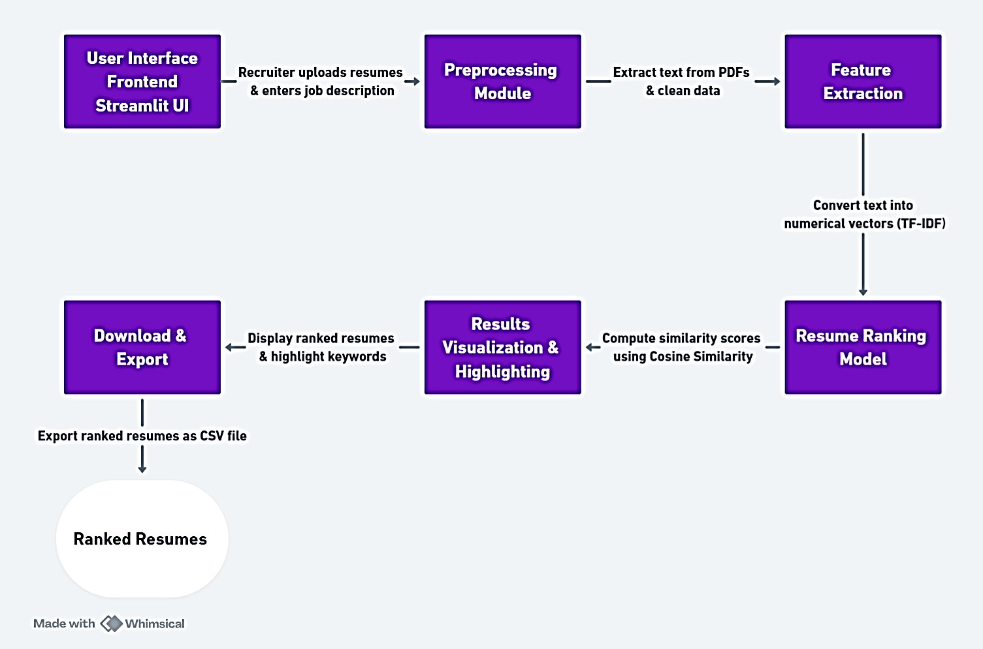

**Figure 3.1: System Design**

**1. User Interface (Frontend - Streamlit UI)**

Role:

The User Interface (UI) serves as the entry point of the system where recruiters interact with the platform.

* Recruiters upload resumes in PDF format.
* They enter the job description (JD) to compare resumes against.
* The UI sends this data to the Preprocessing Module for further processing.

Process:

1. Upload Resume(s):
   * The recruiter selects and uploads multiple resumes in PDF format.
2. Enter Job Description:
   * The recruiter inputs the JD into a text box.
3. Send Data to Preprocessing:
   * The system sends the uploaded PDFs and JD for text extraction and cleaning.

Technology Used:

* Streamlit for building an interactive UI.
* File upload feature to allow users to upload multiple files.
* Text input fields for recruiters to enter job descriptions.

**2) Preprocessing Module**

Role:

This module is responsible for extracting and cleaning resume text from uploaded PDF files.

Process:

1. Extract Text from PDFs:
   * Uses PyPDF2 or pdfminer to extract text from the uploaded resumes.
2. Clean Data:
   * Removes unnecessary elements such as special characters, extra spaces, line breaks, and stopwords.
3. Return Cleaned Data to UI:
   * The cleaned resume text is sent back to the UI for further processing.

Technology Used:

* PyPDF2 for extracting text from PDFs.
* NLTK or SpaCy for text cleaning and preprocessing.

**3) Feature Extraction**

Role:  
The Feature Extraction module is responsible for converting textual resume data into numerical representations, enabling effective comparison with job descriptions.

Functionality:

* Takes the cleaned resume text from the Preprocessing Module.
* Utilizes TF-IDF (Term Frequency-Inverse Document Frequency) to transform text into numerical vectors.
* Assigns weights to words based on their relevance, reducing the impact of common words while emphasizing significant terms.
* Generates structured numerical data that can be used for similarity computation in the Resume Ranking Model.

Input:

* Cleaned text extracted from resumes.

Output:

* Numerical feature vectors representing resume content.

**4) Resume Ranking Model**

Role:

The Resume Ranking Model scores resumes by computing their similarity with the job description.

Process:

1. Apply Cosine Similarity:
   * Compares TF-IDF vectors of each resume with the job description.
   * Scores range from 0 (no match) to 1 (perfect match).
2. Rank Resumes:
   * Resumes with higher similarity scores are ranked higher.
3. Send Results to Visualization Module:
   * The ranking results are sent for display and analysis.

Technology Used:

* Scikit-learn's cosine_similarity for computing similarity scores.
* Matrix operations for efficiently processing multiple resumes at once.

**5) Results Visualization & Highlighting**

Role:

This module displays the ranked resumes with highlighted keywords.

Process:

1. Display Resume Rankings:
   * Shows resumes ranked from highest to lowest based on similarity scores.
2. Highlight Matching Keywords:
   * Keywords from the job description are highlighted in each resume.
3. Enable Recruiters to Review Results:
   * Recruiters can manually check top-ranked resumes.

Technology Used:

* Streamlit components to display ranked resumes.
* Regex and NLP for highlighting important words.

**6) Download & Export**

Role:

Allows recruiters to export ranked resumes in a structured format.

Process:

1. Generate CSV File:
   * Creates a CSV file containing resume details, similarity scores, and highlighted keywords.
2. Enable Download Option:
   * The recruiter can download the CSV file for future use.

Technology Used:

* Pandas to_csv for generating CSV files.
* Streamlit's file download feature for enabling file export.

**7) Ranked Resumes (Final Output)**

Role:

The final output is a CSV file containing ranked resumes.

Process:

1. The CSV file contains candidate names, resume similarity scores, and highlighted keywords.
2. Recruiters can use this list for manual shortlisting.

**3.2 Requirements Specifications**

Requirement specifications define the functional and non-functional aspects of a system to ensure its proper development and implementation. It serves as a blueprint that outlines what the system should achieve, how it should behave, and the constraints it must operate within.

**3.2.1 Software Requirements**

* Programming Language: Python
* Framework: Streamlit (for UI development)
* Libraries & Dependencies:
* PyPDF2 (for PDF text extraction)
* Pandas (for data handling and processing)
* NumPy (for numerical operations)
* Scikit-learn (for TF-IDF transformation and Cosine Similarity computation)
* Matplotlib/Seaborn (for result visualization)
* Text Editor/IDE: VS Code / PyCharm / Jupyter Notebook

**CHAPTER 4**

**Implementation and Result**

**4.1 Snap Shots of Result:**

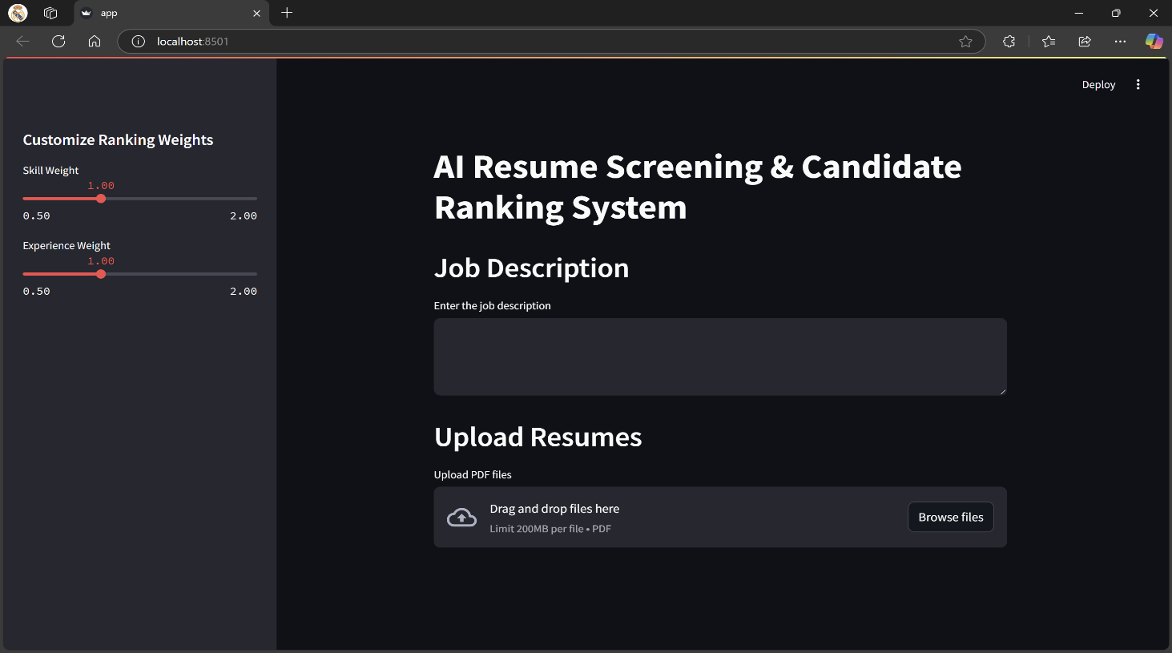

**Figure 4.1: Start Screen or Home**

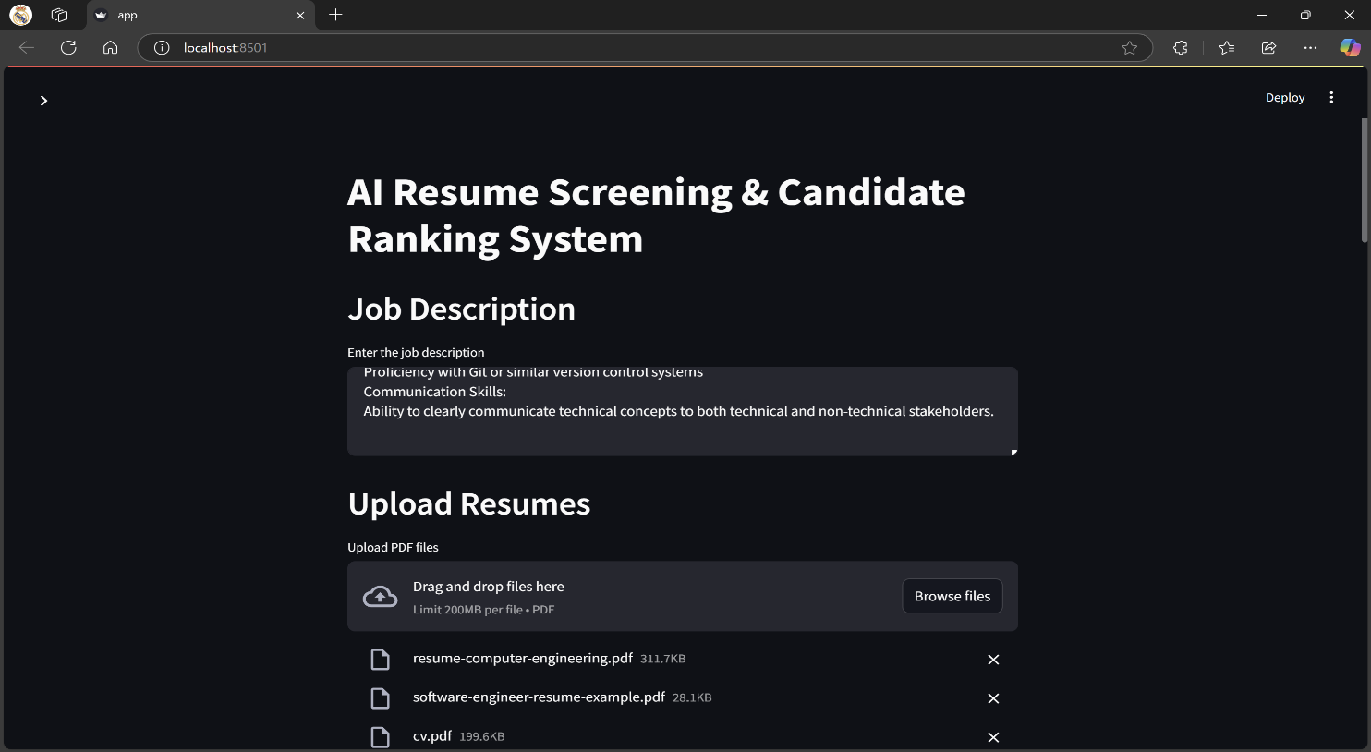The home page of the project provides a simple interface for recruiters to upload resumes and enter job descriptions. It serves as the main entry point, allowing users to initiate the resume screening and ranking process.

**Figure 4.2: Resume and Job Description Upload**

The second snapshot captures the stage where recruiters have uploaded resumes and entered the job description. At this point, the system begins preprocessing the resumes by extracting text and cleaning the data for further analysis.

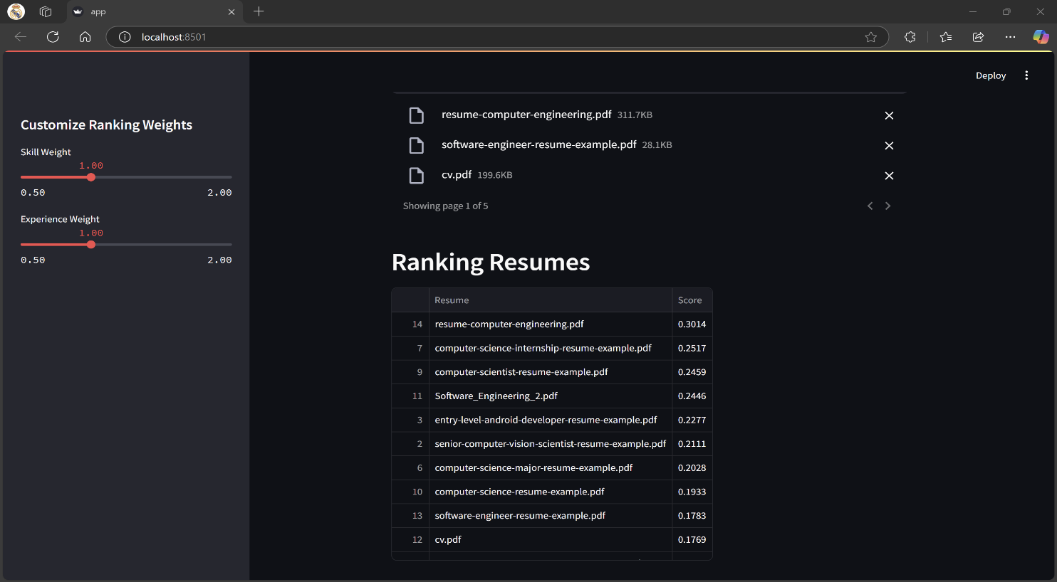

* 1. **GitHub Link for Code:**

**Figure 4.3: Ranked Resumes**

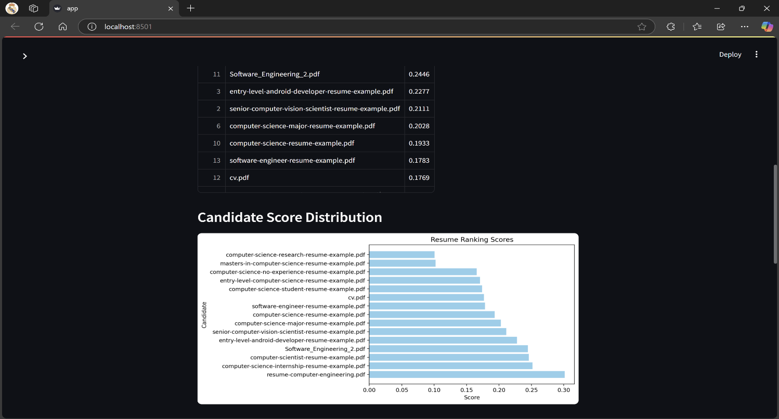The third snapshot displays the ranked resumes in a structured table format. Each resume is assigned a similarity score based on its relevance to the job description, helping recruiters quickly identify the most suitable candidates.

**Figure 4.4: Visualized Representation**

The fourth snapshot presents a bar chart visualization of the resume ranking scores. This graphical representation helps recruiters easily compare candidates based on their similarity to the job description.

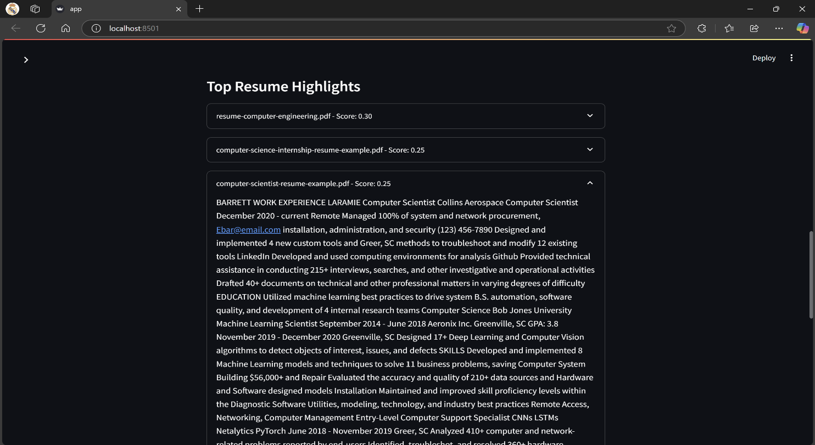

**Figure 4.5: Top Resume Highlights**

The fifth snapshot displays the top resume highlights, where users can select a preferred resume from a dropdown menu. It showcases key extracted text with highlighted keywords, allowing recruiters to quickly review relevant information.

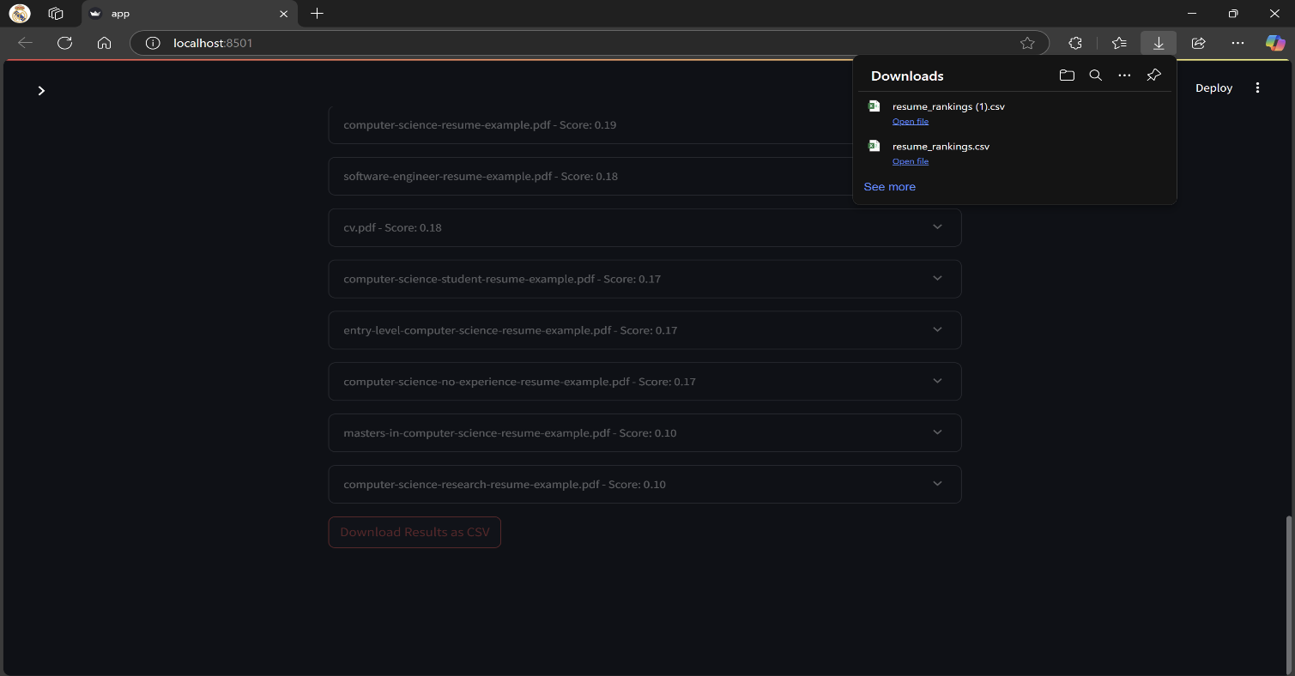

**Figure 4.6: Download Results as CSV File**

This snapshot shows the option for users to download the ranked resume results as a CSV file. This feature allows recruiters to save and analyze the shortlisted candidates for further evaluation.

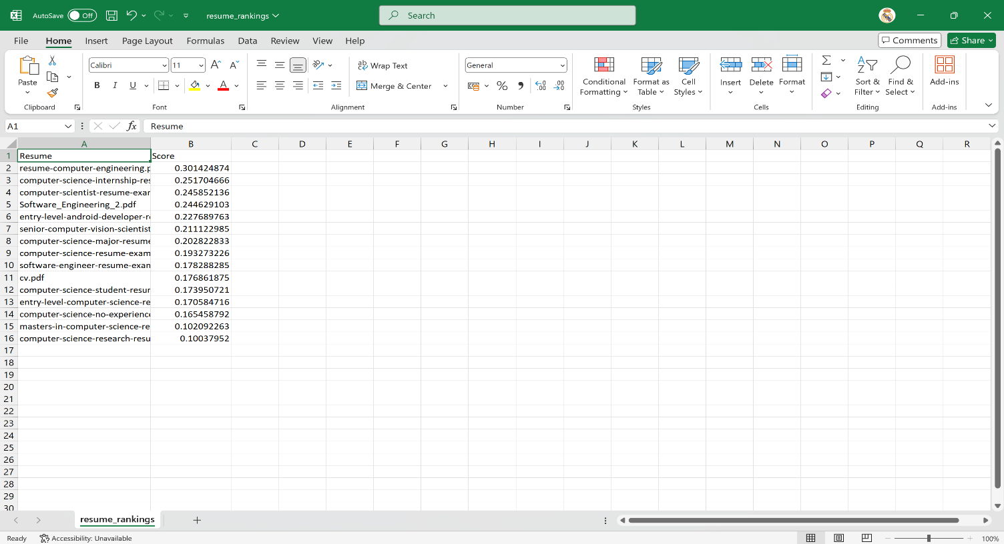

**Figure 4.7: CSV File of Results**

The final snapshot displays the CSV file containing the ranked resume results. It includes candidate names, similarity scores, and other relevant details, providing a structured format for further analysis and decision-making.

**4.2 GitHub Link for Code**

[**https://github.com/KandukuriAbhinav-03/AICTE-AI-POWERED-RESUME-SCREENING-AND-RANKING-SYSTEM**](https://github.com/KandukuriAbhinav-03/AICTE-AI-POWERED-RESUME-SCREENING-AND-RANKING-SYSTEM)

**CHAPTER 5**

**Discussion and Conclusion**

**5.1 Future Work**

The AI-powered resume screening device offers an green manner to rank applicants primarily based totally on task descriptions. However, there are numerous improvements that may be carried out to enhance its accuracy, fairness, and usability.

* 1. Advanced NLP and AI Models: Future variations of the device can combine deep gaining knowledge of fashions like BERT, GPT, or transformer-primarily based totally architectures for greater particular textual content evaluation and candidate rating. This will assist in higher knowledge the context of resumes and task descriptions.
  2. Integration with ATS Platforms: To streamline recruitment workflows, the device may be incorporated with present Applicant Tracking Systems (ATS), permitting recruiters to manipulate resumes greater effectively with out switching among unique tools.
  3. Multi-Format Support: Expanding assist past PDFs to consist of DOCX, TXT, and scanned pictures the use of Optical Character Recognition (OCR) will make the device greater flexible and accessible.
  4. Industry-Specific Customization: Creating domain-precise fashions tailor-made to unique industries (e.g., IT, healthcare, finance) can enhance the accuracy of candidate critiques primarily based totally on sector-precise requirements.
  5. Bias Mitigation and Fairness Enhancement: AI bias stays a primary challenge in recruitment. Future upgrades can cognizance on fairness-conscious algorithms that make certain impartial rating of applicants primarily based totally on abilities and revel in instead of demographic elements.
  6. Real-Time AI Chatbot Assistance: Adding an AI-powered chatbot can help recruiters and applicants via way of means of imparting automatic responses to

often requested questions, guiding candidates in resume upgrades, and supporting recruiters with hiring decisions.

* 1. Enhanced Data Visualization and Reporting: More interactive dashboards with certain analytical insights may be brought to assist recruiters higher recognize candidate ratings and choice trends.
  2. Weight-Based Ranking Improvements: Introducing a greater subtle weighted scoring device that offers recruiters more manipulate over elements like revel in, abilities, certifications, and training can enhance decision-making.

**5.2 Conclusion**

The AI-primarily based totally Resume Screening and Candidate Ranking System offers an green and automatic method to comparing activity applicants. By leveraging Natural Language Processing (NLP) and Machine Learning (ML) techniques, the device complements the hiring technique via way of means of rating resumes primarily based totally on their relevance to a given activity description. The system's ability to extract text from resumes, compute similarity scores, visualize rankings, and highlight key information significantly reduces the time and effort required for manual resume screening.

The project successfully addresses common recruitment challenges, such as filtering through large volumes of resumes and ensuring fair candidate evaluation. The integration of customizable rating weights permits recruiters to alter the significance of various factors, enhancing flexibility and decision-making. Additionally, the device consists of capabilities like key-word highlighting, facts visualization, and CSV export, in addition improving its usability and practicality.

Despite its advantages, the assignment has sure limitations, which include capacity biases in textual content-primarily based totally rating and constrained aid for non-textual resumes. The destiny scope consists of integrating deep getting to know fashions for stepped forward accuracy, helping a couple of file formats, mitigating biases, and growing real-time AI assistance. Enhancements like ATS integration and domain-unique fashions will in addition amplify the device`s applicability in expert hiring.Overall, this assignment contributes to the development of AI-pushed recruitment answers via way of means of imparting a scalable, green, and goal method to renew screening. By automating and optimizing candidate evaluation, the device streamlines hiring processes, permitting recruiters to attention on higher-degree decision-making and enhancing the general performance of expertise acquisition.

**REFERENCES**

[1]. Thomas, R., & Chen, P. (2022). "Machine Learning Approaches to Resume Screening and Candidate Ranking." *International Journal of Artificial Intelligence*, 16(2), 101-112.

[2]. Zhao, W., & Liu, Z. (2023). "Deep Learning-Based Resume Screening for Efficient Candidate Selection." *Journal of Computational Intelligence in Recruitment*, 8(1), 22-30.

[3]. Harris, L., & Lewis, P. (2021). "AI-Driven Resume Screening: Trends and Challenges." *Journal of Human Resource Technologies*, 14(3), 45-58.

[4]. Kumar, P., & Bhagat, S. (2023). “Optimizing Hiring Processes with Resume Ranking Using AI.” *Artificial Intelligence Applications in Business and Industry*, 12(4), 99-111.

[5]. Zhang, X., & Huang, J. (2022). “Enhancing Recruitment with Automated Resume Ranking: A Survey on AI-Based Models.” *Journal of Employment Technologies*, 19(2), 90-104.

[6]. Singh, A., & Desai, A. (2021). “NLP and Machine Learning for Resume Screening: A Review of Approaches.” *Proceedings of the International Conference on AI and Data Science*, 200-2.

[7]. Carter, M., & Patel, R. (2024). “AI-Powered Resume Screening: Ethical Considerations and Bias Mitigation.” *AI Ethics Journal*, 7(5), 410-421.

[8]. Choudhary, V., & Jain, R. (2023). “A Comparative Study of AI Algorithms for Resume Screening.” *International Journal of Machine Learning and Applications*, 25(1), 115-125.

[9]. Williams, G., & Gupta, T. (2024). "AI-Based Automated Resume Evaluation System for Improved Recruitment Efficiency." *International Journal of Business Intelligence and Analytics*, 22(2), 50-63.

[10]. Patel, M., & Shah, R. (2022). "Artificial Intelligence and Human Resources: Transforming Resume Screening Systems." *Journal of Employment Technology*, 28(4), 76-85.

[11]. Singh, R., & Roy, A. (2023). "Building an AI-Powered Resume Screening Tool: A Case Study." *Journal of Artificial Intelligence in HR*, 5(3), 131-142.

[12]. Anderson, J., & Green, F. (2021). "AI in Recruitment: Resume Screening and Bias Detection Algorithms." *Proceedings of the IEEE International Conference on Human-Computer Interaction*, 44-55.

[13]. Sharma, M., & Gupta, R. (2023). "AI-Driven Resume Ranking Using BERT and Deep Learning Models." *Journal of Computational Recruitment Systems*, 13(6), 230-242.

[14]. Verma, P., & Joshi, S. (2024). "AI for Resume Screening: Improving Candidate Selection in Large-Scale Recruiting." *Journal of AI and Automation in Employment*, 11(2), 89-102.

[15]. Joshi, N., & Shah, S. (2024). "Automated Resume Evaluation with AI: An Overview of Existing Frameworks." *Journal of Artificial Intelligence in Recruitment*, 9(1), 33-45.

[16]. Lee, H., & Park, J. (2023). "Application of Natural Language Processing for Automated Resume Screening." *Journal of AI and Human Resources Management*, 10(4), 215-229.

[17]. Zhang, L., & Wang, Y. (2022). "Enhancing Recruitment Processes with AI-Driven Resume Matching Systems." *AI in Human Resource Technology*, 16(1), 77-90.

[18]. Nguyen, D., & Tan, M. (2024). "Leveraging Deep Neural Networks for Resume Screening and Job Matching." *International Journal of Computational Recruitment*, 9(3), 102-115.

[19]. Suresh, K., & Nair, A. (2021). "AI-Based Resume Ranking Systems: A Review of Algorithms and Implementation Strategies." *Journal of AI and Machine Learning in Recruitment*, 7(2), 45-58.

[20]. Patel, V., & Bansal, M. (2024). "Optimizing Talent Acquisition with AI: A Study on Automated Resume Screening Techniques." *Journal of Technology in Recruitment and Employment*, 18(5), 134-146.